Unit 5 End of Unit Project: Predictive Modeling and Deployment
An MLOps lifecycle for a risk classification model

1. Project objectives and significance
The goal was to build, version, deploy and monitor a classification model the way a production MLOps team would, not just to train a model in a notebook. In healthcare analytics (for example, predicting 30-day readmission risk), a model that is accurate on day one but unversioned, untested or unmonitored can quietly become unsafe as patient populations change. This project demonstrates the full lifecycle: data preparation, modelling, version control, automated CI/CD, a secured REST API, and drift monitoring.
Dataset note. The supplied dataset is the Titanic passenger data (891 rows, 12 columns), so the model predicts survival (Survived) as a stand-in for a risk outcome. The pipeline is dataset-agnostic: feature lists live in one configuration file.

2. Pipeline architecture and tool integration
Stage | Tool | Output
Data versioning | DVC | titanic.csv.dvc, dvc.yaml
Preprocessing and features | pandas, scikit-learn | train.csv, test.csv
Training and tracking | scikit-learn, MLflow | model.joblib, logged params, metrics, model artifact
Automation | pipeline.py, GitPython, GitHub Actions | tests, quality gate, Git tag, uploaded artifacts
Serving | FastAPI, Uvicorn, Docker | /predict, /health
Monitoring | Evidently AI | HTML drift and performance reports, JSON summary, alert
Flow: raw data (DVC) -> preprocess -> train (MLflow) -> pytest -> quality gate (ROC-AUC >= 0.80) -> monitoring report -> Git tag -> deploy API -> log predictions -> Evidently drift check -> retrain if alerted.

3. Data exploration and preprocessing
- About 38% of passengers survived (class balance 62% / 38%), so accuracy alone is misleading and recall and ROC-AUC matter.
- Strong patterns: survival was 74% for women vs 19% for men, and 63% / 47% / 24% for passenger classes 1 / 2 / 3.
- Missing values: Age 177 (filled by median age per title), Embarked 2 (mode), Cabin 687 (dropped, 77% missing).
- Outliers: Fare clipped at the 1st and 99th percentiles.
- Feature engineering: Title extracted from Name, FamilySize, IsAlone.

4. Model development and evaluation
A Random Forest (300 trees, max depth 6, min leaf size 3) in a scikit-learn Pipeline with scaling and one-hot encoding, evaluated on a stratified 20% hold-out set (179 rows).
Metric | Result
Accuracy | 0.8156
Precision | 0.8103
Recall | 0.6812
F1-score | 0.7402
ROC-AUC | 0.8560
Recall (0.68) is lower than precision (0.81): the model misses about a third of true positives. If the real use case were readmission, where missing a high-risk patient is costly, the decision threshold should be lowered to trade precision for recall.

5. Versioning
Every training run is logged to MLflow (parameters, five metrics, feature list, row count, and the model). DVC tracks the raw data and defines a reproducible two-stage pipeline (dvc repro). Git versions all code, and each approved model receives a Git tag containing its timestamp and ROC-AUC.

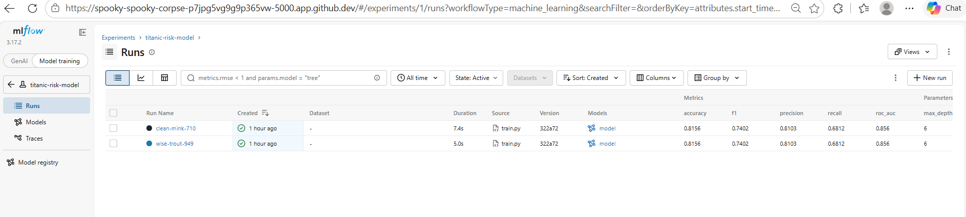
Figure 1: MLflow experiment page showing two tracked runs with identical metrics, demonstrating reproducibility.

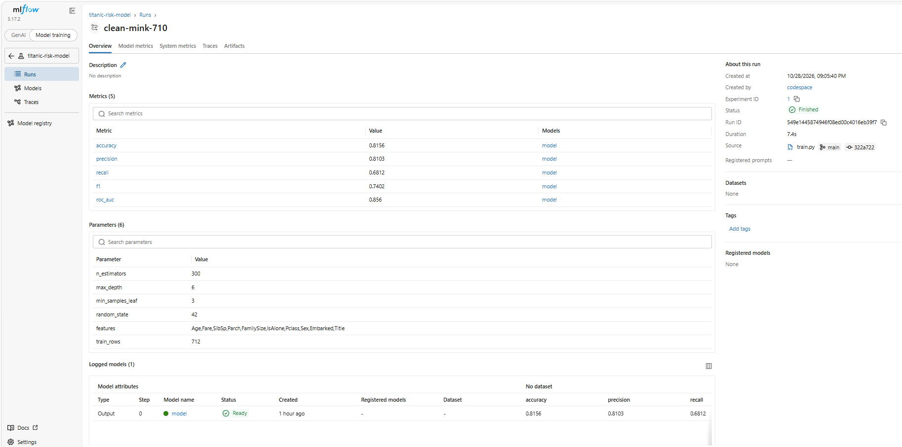
Figure 2: All Parameters, Metrics, and Model Artifacts.

6. CI/CD
pipeline.py automates preprocessing, training, testing, quality gate, monitoring and tagging. Its “—watch” mode re-runs the pipeline when data or code changes. The GitHub Actions workflow triggers on code or data pushes, pull requests, a weekly schedule and manual dispatch, then uploads the model and reports and builds a Docker image. The test suite has 7 automated tests: two for preprocessing (title extraction and no missing values after cleaning), one for model quality (minimum ROC-AUC and accuracy), and four for the API (health check, API-key authentication, valid predictions, and rejection of invalid input). All tests pass.

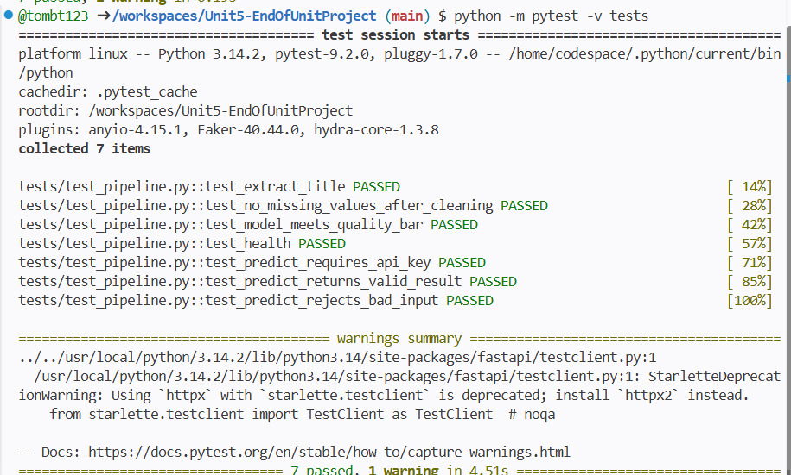
Figure 3: Automated test suite (7 tests) covering preprocessing, model quality, and the API. All tests pass.

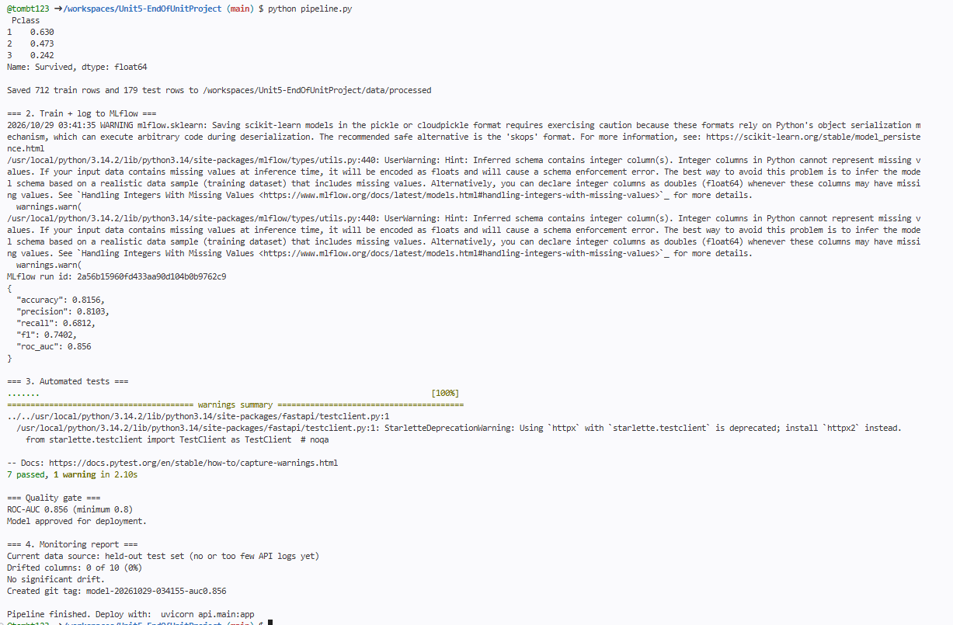
Figure 4: Automated pipeline run covering training, tests, quality gate, monitoring report and release tag.

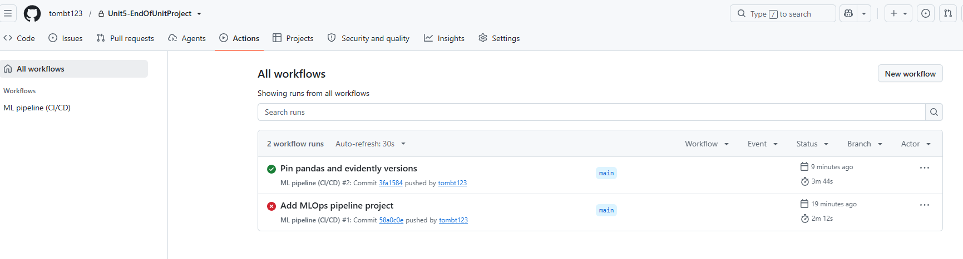
Figure 5: GitHub Actions runs.

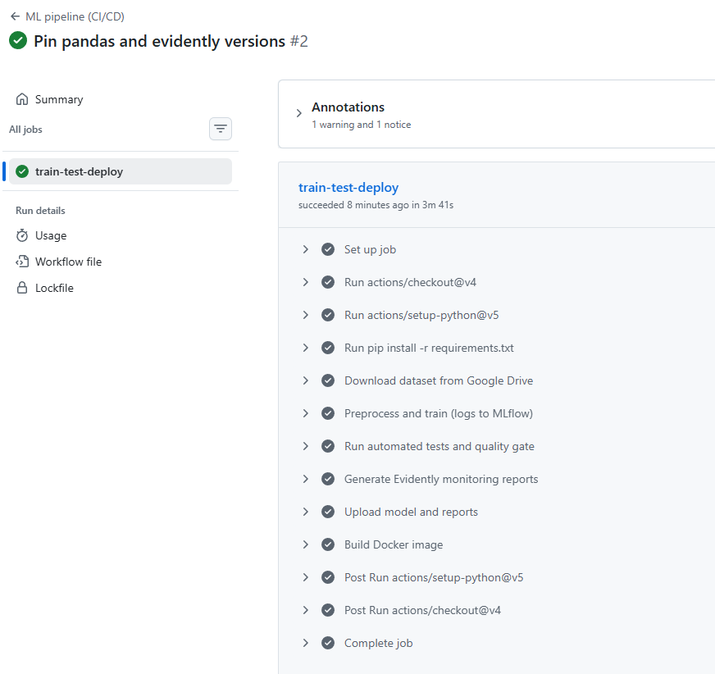
Figure 6: ML Pipeline Run Summary.

7. Deployment
The FastAPI service exposes POST /predict and GET /health to the Internet. Security and robustness features include: API-key header authentication (401 without it), Pydantic validation (422 for invalid values such as negative age), the same feature engineering as training, and logging of each request for monitoring. Example response for a 30-year-old first-class woman: {"prediction": 1, "probability": 0.9797, "risk_level": "high"}.

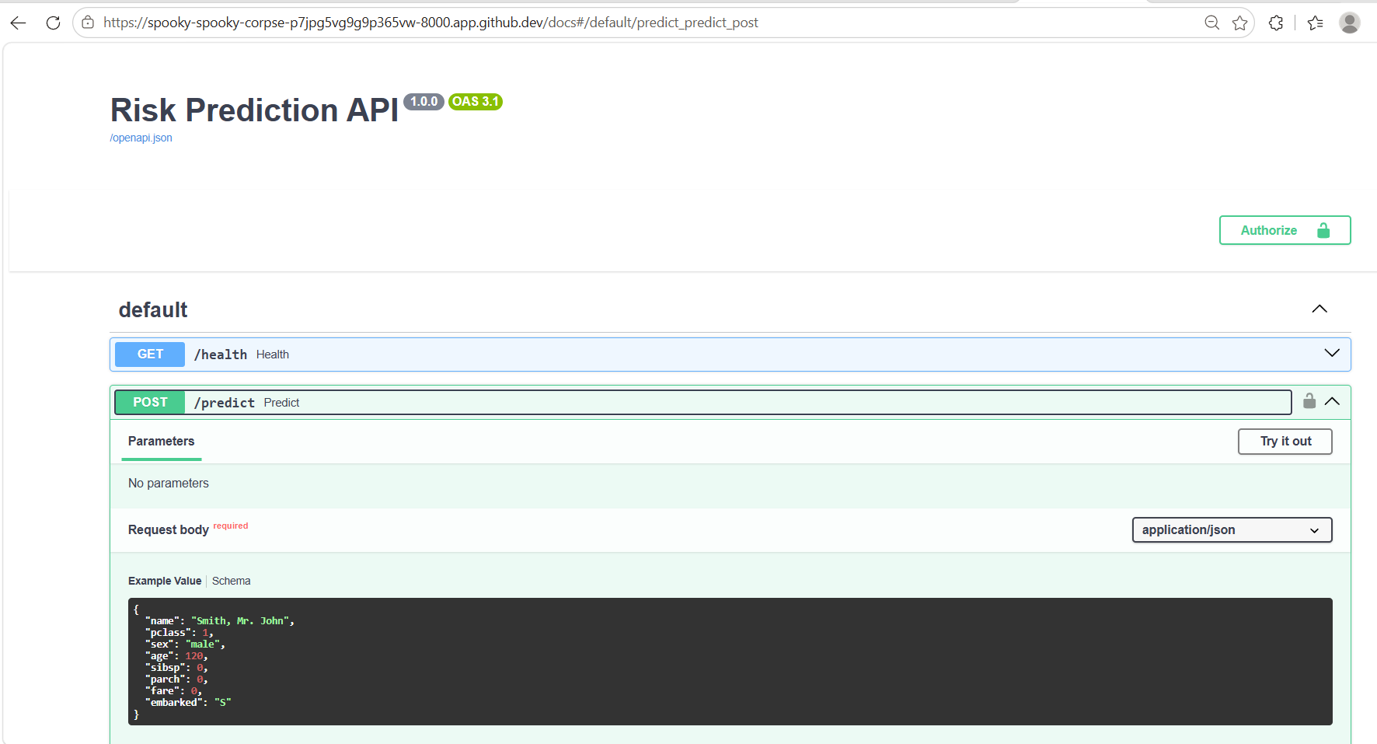
Figure 7: FastAPI interactive documentation page showing the /health and /predict endpoints.

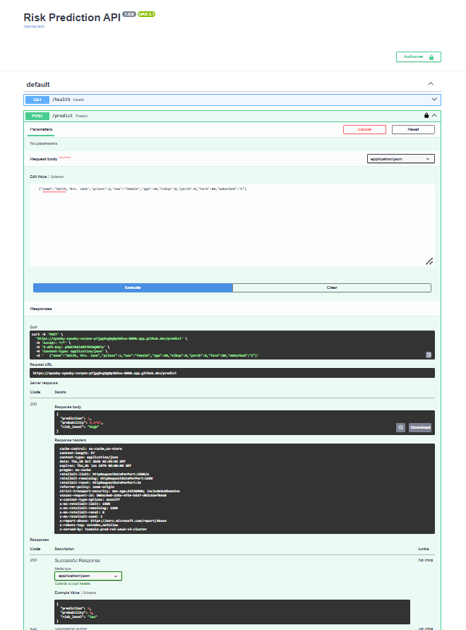
Figure 8: Successful POST /predict request returning a 200 response with the prediction, probability and risk level.

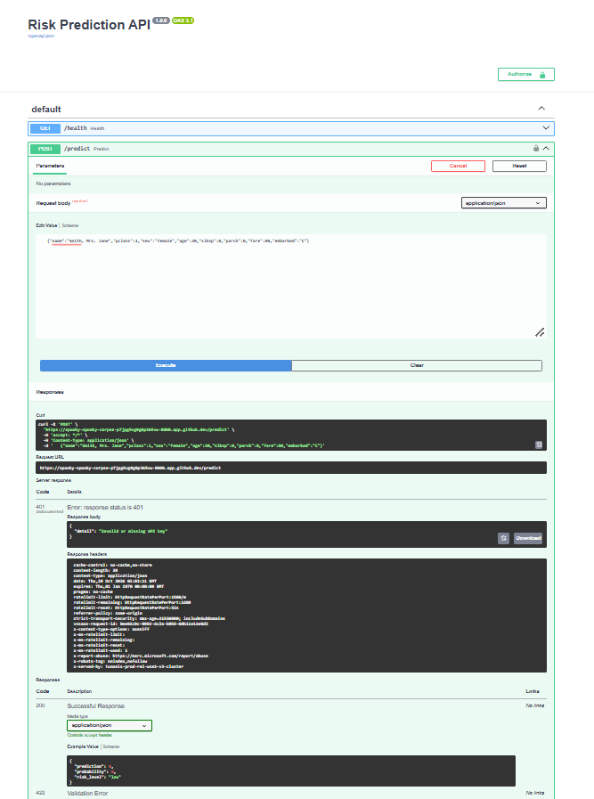
Figure 9: A request without a valid API key is rejected with a 401 error.

8. Monitoring
Evidently AI compares training data (reference) with live API traffic. Comparing the training data to the held-out test data, 0 of 10 columns drifted (no alert). A deliberately simulated shift (Age +18 years, Fare x2.5) made 2 of 10 columns (20%) drift, which crossed the 20% threshold and triggered an alert (exit code 1). Reports produced: data_drift.html, data_drift_simulated.html, model_performance.html, summary.json.

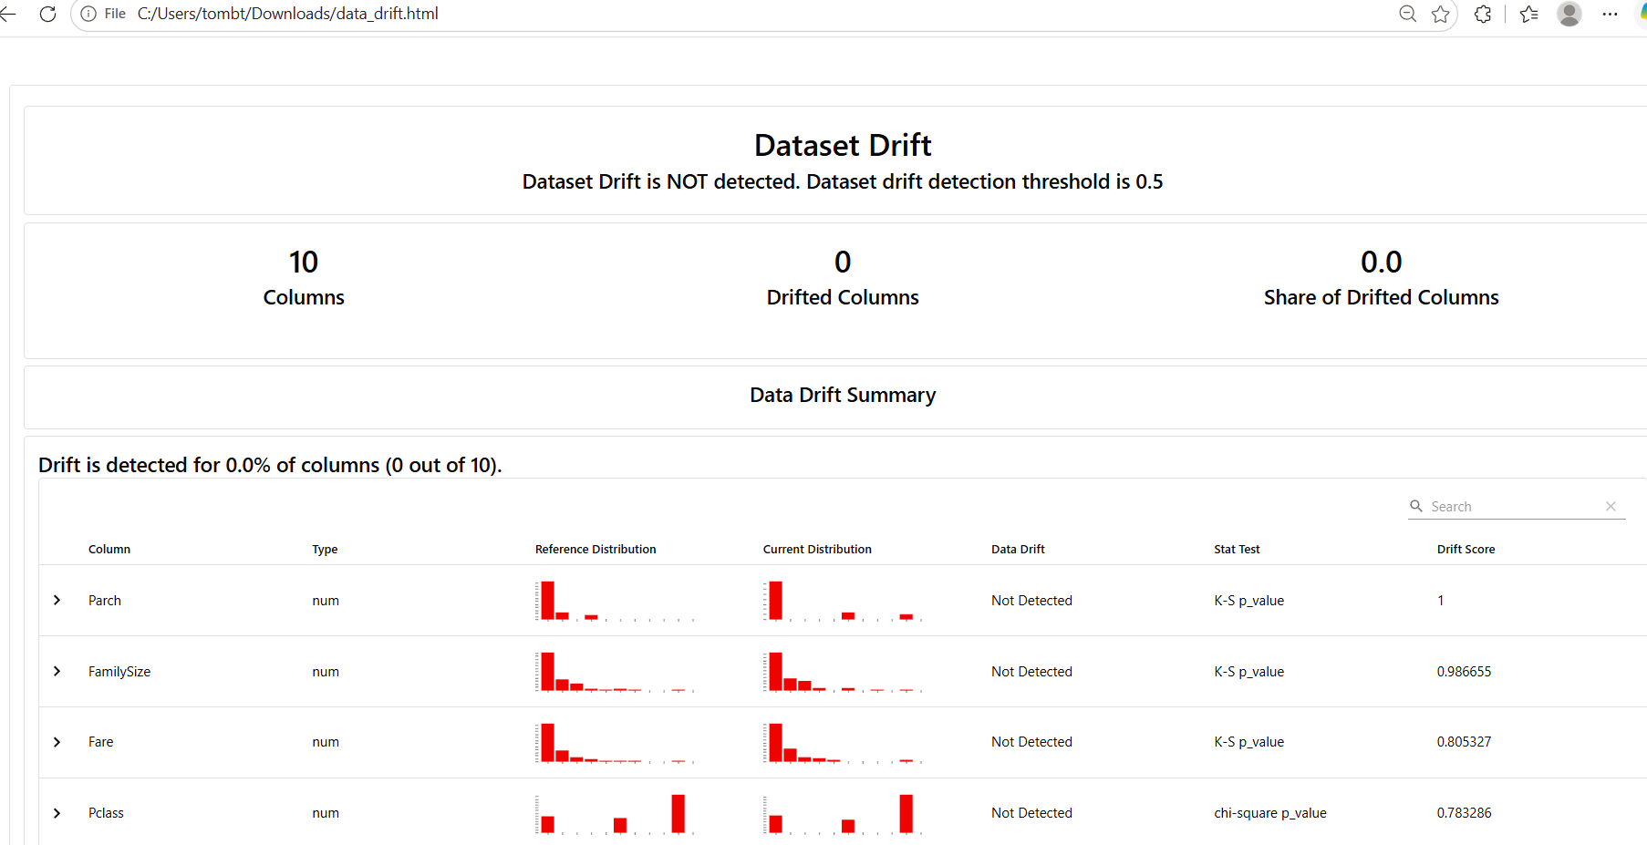
Figure 10: Evidently data drift report. No drift detected between the training data and the current data.

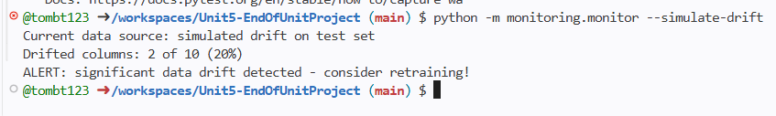
Figure 11: Monitoring script raising a drift alert on deliberately shifted data (Age and Fare). In production this alert would trigger retraining.

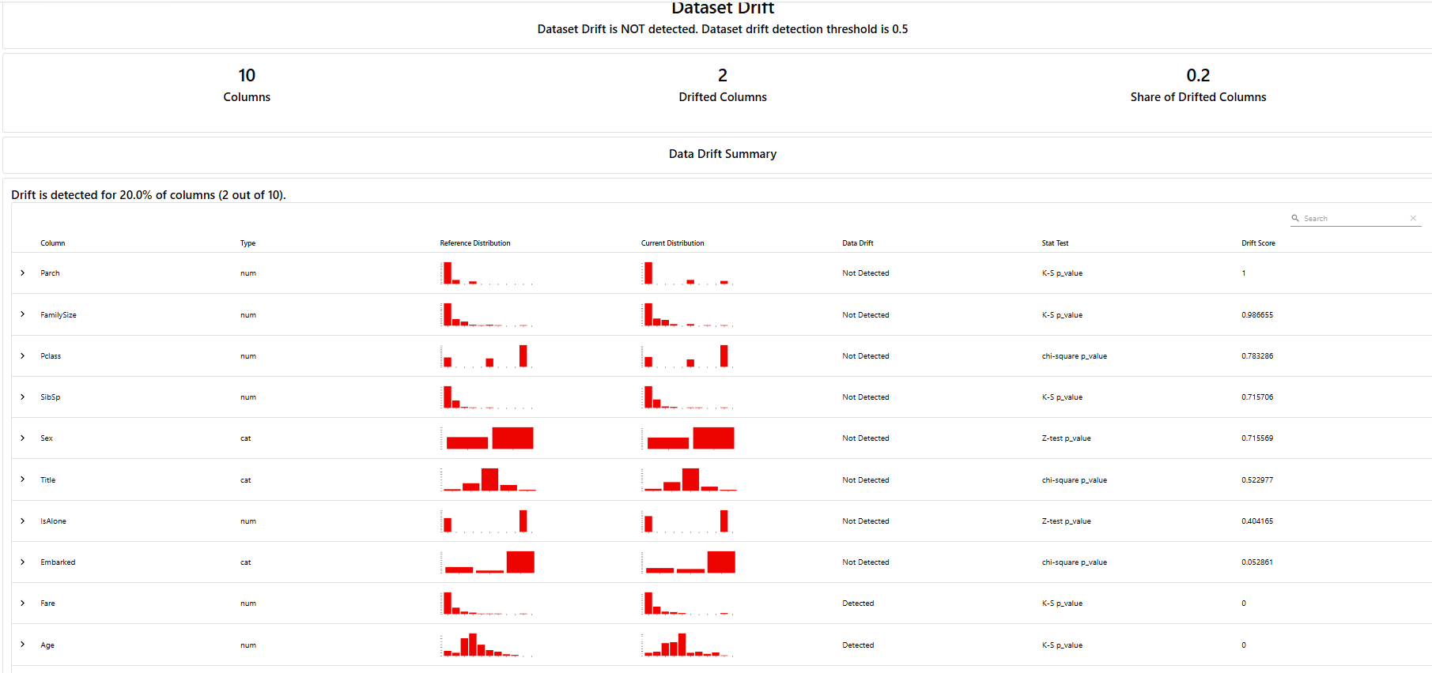
Figure 12: Evidently data drift report on simulated data. Age and Fare are flagged as drifted (2 of 10 columns, 20%).

Evidently’s built-in banner uses a 50% threshold, so it reads ‘not detected.’ The monitoring script alerts at a stricter 20%, which is why the alert in Figure 11 fired.

9. Lessons learned
- Putting preprocessing inside the saved model pipeline prevents training/serving skew.
- MLflow 3 saves models with a “trusted types” check by default; Random Forests required explicitly choosing cloudpickle for models we trained ourselves.
- A drift threshold must be tuned: at 30% the simulated shift went undetected, at 20% it was caught. Too low causes alert fatigue.
- Drift detection works without labels, but performance monitoring needs true outcomes, which can arrive late.
- The small test set (179 rows) makes metrics noisy, so cross-validation would give more reliable estimates.
- The first GitHub Actions run failed because an unpinned pandas version was incompatible with Evidently. Pinning exact versions in requirements.txt fixed it, which shows why reproducible environments matter.

10. Future recommendations
- Use a real readmission dataset, with fairness checks across demographic groups and privacy controls (HIPAA/GDPR).
- Tune hyperparameters and compare models (Logistic Regression, XGBoost) with cross-validation, and calibrate probabilities.
- Use an MLflow tracking server and model registry with staged promotion (Staging, Production).
- Configure a DVC remote (cloud storage) and schedule monitoring with automated Slack or email alerts.
- Replace the demo API key with a secrets manager and OAuth, add rate limiting, and store prediction logs in a database.

